CPSC 488 Group 1 Installation Manual

1. After cloning the repository into eclipse, it should look like this in the project explorer:

1. Now right click WorkOrders in the explorer and select configure build path.

1. You will then need to click on Build Path and under it choose configure Build Path:

1. Next is once it opens up the source menu checking to make sure that you’re exclusions say none below underlines the specific problematic one to check:

If it is excluded here you can hit edit and then when it brings up a menu mentioning exclusion and inclusion patterns ensure the exclusion patterns are empty. When you’re finished here hit apply and close.

1. Our project has support for mySQL or the memory based H2 database system, both can be used, it is fully up to the user to decied which they want, it is just a matter of taking the proper .txt file information and copy-pasting the information into the application.properties folder. Both are explained below:
   1. mySQL

With the mySQL information into the application.properties file, make sure the username and password are properly set up, and a schema called ‘workorders’ should be created with tables for USERS and INCIDENTS when the program runs.

If setup for mySQL it should look like below:

* 1. H2

With the H2 information in the application.properties folder, the only matter that the user will have to do is go to localhost:8080/h2-console to see what the database has, and remember to copy and paste the datasource url and ensure the drive class name is correct in the browser; there are ours below:



1. Now you need to run the WorkOrdersApplication.java file as a java application:

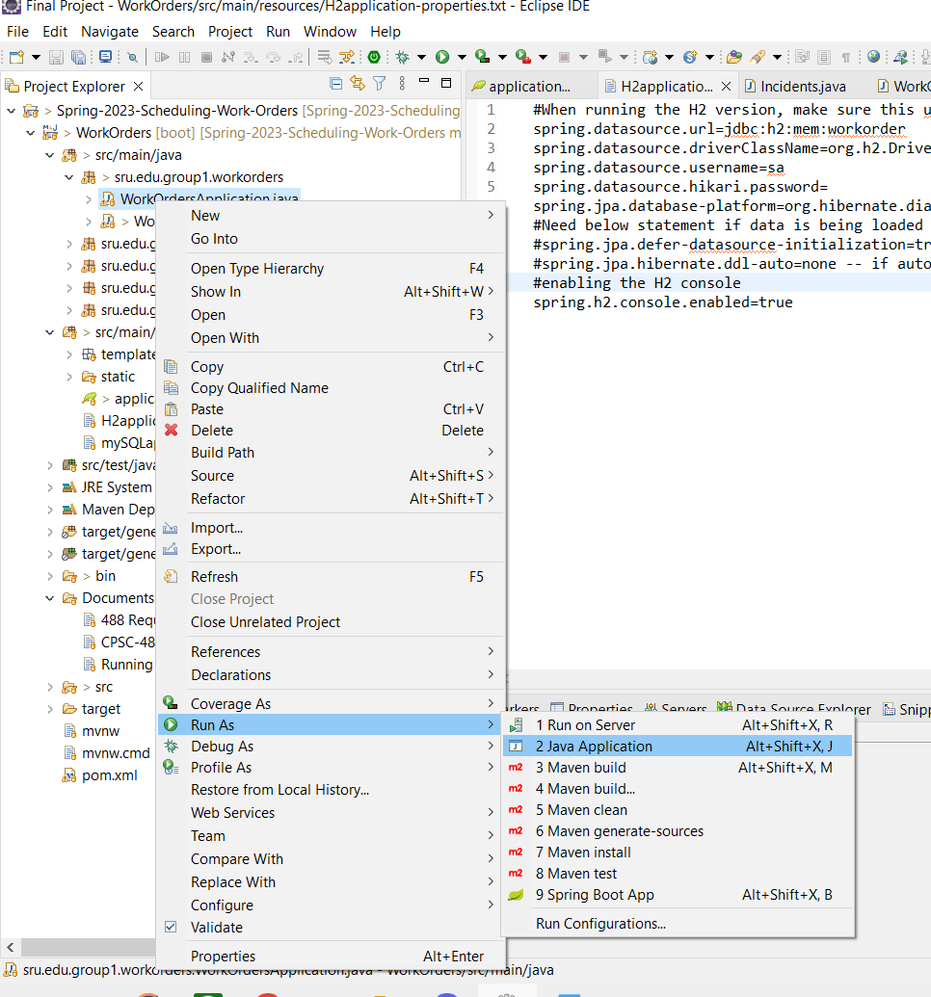

1. After Running this, open your web browser and go to localhost:8080. You should be greeted by this page.

1. **At this point you can choose to register a new user account or login:  
   8.1 Login**

(*Note you can only login if you already have registered or have pre-existing account information for our application in your mySQL table. It comes with none on download / initial setup.*)

If sign is is successful it will look like this:

**8.2 Registration**

For this step all you need to do is fill in your information and hit sign up. The page will alert you if your informtion is wrong. E-mails are the only field here that must be unique.Graphical user interface, application

On succesful signup:

You also will be emailed on registration an e-mail from our system thanking you for registering.

1. User Landing

When at User Landing you have two options, reporting an incident or viewing active incidents for you as a user.

9.1 Submitting an Incident Report:

9.1.1 Choosing Issue type:

Here you can just choose an option type and click on a button, they all have a similar flow.

9.1.2 FAQ Page:

(FAQ is currently empty since it felt like something we can fill out later and wanted the program’s structure to be prioritized instead)

Next, click the button:

9.1.3 Incident Report Form:

After you fill it out you can hit submit and if it has no error it will send you back to User Landing! After this, you can check to see if incident and user data was put into your database via the tables!

9.2 Viewing User Incidents:

If the user has any existing incidents it will display them like below, otherwise it will be empty:

heading to Localhost:8080/h2-console with the h2 settings and using the proper info will get you these tables:

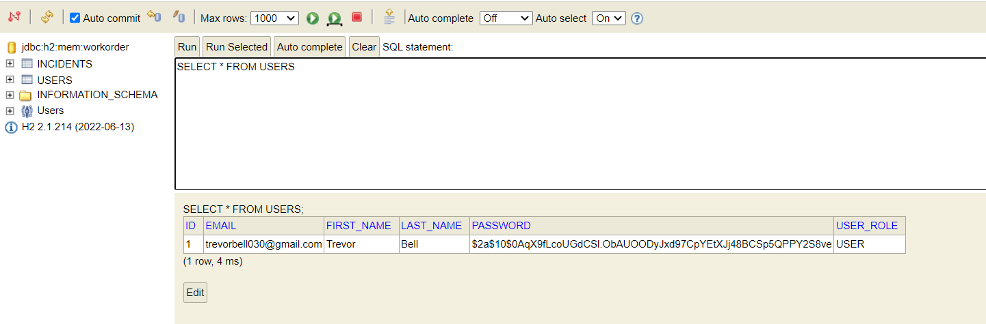

And one for the incident that was submitted:

and if mySQL was used, then it should appear like below:

(Users above, Incidents below!)

